Nolte Chapter 17: The Visual System

The retina is an outgrowth of the diencephalon.

The outermost tissue layer is continuous with the dura matter and is mostly the sclera (white of the eyes) which toninues posteriorly as the sheath of the optic nerve.

The cornea lets light into the eye.

Uvea is the highly vascularized middle layer and is sandwiched betweent he sclera and the retina as a densely pigmented choroid and absorbs stray light. It continues anteriorly to form the bulk of the ciliary body and stroma of the iris.

The outer portion of the retina is the retinal pigment epithelium and the inner portion is the neural retina. The photosensitive retina ends anteriorly at a serrated border (ora serrate).

Most of the refraction occurs at the air-water surface at the front surface of the cornea. The lens wants to be round. Ciliary muscles can contract to allow the lens to return to a more rounded state.

The lens is suspended by strands of connective tissue called zonules. At rest the lens is slightly flattened and the eye is focused on distant objects.

The ciliary muscle is oriented circumferentially so that contraction of these fibers pulls the ciliary attachment points of the zonules toward the center of the pupil and relaxes some of the tension in the zonular suspension. Like a sphincter. Circular msucles. Parasympathetic – ciliary ganglion.

Others are oriented parallel (radial) and pullt he ciliary attachment points partly anterior and partly toward the center of the pupil. Contracting the ciliary muscle allows the lens to fatten as the eye accommodates to near objects. Sympathetic – superior cervical ganglion. Dilation. Lateral horn of spinal cord.

Photoreceptor cells terminate on bipolar and horizontal cells that spread laterally and interconnect receptors, bipolar cells, and other horizontal cells. Bipolar cells terminate on ganglion cells and amacrine cells. Axons of ganglion cells leave the eye as the optic nerve.

The 10 layers of retina

- Retinal pigment epithelium
  - One side adjoins the choroid the other surrounds the outer portions of the receptor cells and involved metabolically with receptors.
- Rods and Cones
  - Outer segment of rods are long and cylindrical whereas cones are shorter and tapered. Both are filled with membranous, flat sacs, or disks. Cones some of the disks are continuous with extracellular space, but rads are intracellular.
  - The visual pigment is called rhodopsin in rods and cone pigments(photopsins) in cones.
  - Photons traversing the otuer segment must pass through thousands of sheets of membrane, each full of visual pigment molecules.
  - Absorbed photons help relay a receptor potential
  - Each outer segment is connected to the inner segment by a ciliary stalk.
  - Old disks get phagocytosed by pigment epithelium.
- Outer limiting membrane
  - Muller cells – glial
- Outer nucleur
  - Cell bodies of rods and cones
- Outer plexiform
  - Synaptic zone where recptors terminate on horizontal and bipolar cells.
- Inner nuclear
  - Cell bodies of interneurons. Horizontal, bipolar, and amacrine
- Inner plxiform
  - Bipolar cells terminate on amacrine and ganglion cells and processes of amacrine spread laterally.
- Ganglion cell layer
  - Cell bodies of ganglion cells whose dendrited ramify the inner plexiform and whose axons elave as the optic nerve.
  - There is massive convergence here since there are 5 mil cones and 100mil rods but only 1 mil ganglion.
- Nerve Fiber layer
  - Collection of axons of ganglion that converse like spokes. Also where the opthalamic artery traverses the optic nerve
- Inner limiting membrane
  - More muller cells.

There are no photoreceptors, interneurons, or ganglion cells at the optic disk (blind spot).

Beginning near the lateral edge of the optic disk there is a circular portion of the retina ahd contains a blue absorbing pigment and is yellowish in color and is known as the macula. The venter of the macula is the fovea which is rich in cones (1 to 1 connections with midget ganglia cells. By way of midget bipolar. No rods. Rods increase and cones decrease as we move laterally from macula). This region has the highest acuity. Many of the inner layers are pushed aside.

Opsin enables photopigments to absorb visible light and slight differences among opsid of rods and the three types of cones result in differences in the wavelengths absorbed preferentially by each photopgiment. Opsin activates transducin which can cause a cascade after hydrolyzing cGMP. The surface mebranes of rod and cones outer segments contain cGMP gated ion channels. In the dark, the cGMP concentration is relatively high, and a currently carried mainly by Na ions flows into the outer segment. Thus, there is a depolarized resting potential that release glutamate at a constant rate. cGMP hydrolysis causes cation cahnnels to close and the membrane hypoerpolarizes the potassium equilibirium and transmitter release declines.

So, absorption of a photon prevents millions of ions from entering and ceases firing.

Rods can only respond up to moonlight levels of light intensity and cannot discriminate color.

Responses of multiple rods must be pooled to produce meaningful changes in the firing rate of ganglion cells in response to dim light. 1k rods to 100 bipolar to 1 ganglion.

Cones are less sensitive but faster and require moonlight or greater. There is less convergence with cones than rods.

We use Rods for scotopic, both rods and cones in moonlight(mesopic), and cones for brighter than moonlight (photopic).

Cones are long, middle and short wavelength. Red, green, blue.

Trichromatic takes a multiple integration of these firings (across a tuning curve) and uses multivariate matching to provide information about any wavelength. S cones are only 5% prominent and L and M are intermingles.

Receptive fields are retinal areas in which changing conditions of illumination produce an alteration in of the cell’s activity. This can result in border detection from a multitude of on-center off center / surround type cells.

Some bipolar cells depolarize and other hyperpolarize in response to lamination because glutamate has different effects on them. Illumination of a given receptor can cause it to hyperpolarize and release less glutamate, but illumination of its neighbors might do the opposite. This process can be mediated by horizontal cells. Glutamate released by receptors depolarizes horizontal cells, illumination removes this depolarization causing them to hyperpolarize. Hyperpolarization spreads through horizontal cells processes where it increases Ca influx and glutamate release. For example in fovea each cone synapses on two midget bipolar cells. One depolarizes and one hyperpolarizes. These then synapse on two ganglion cells one of which will fire faster whether light intensity increases or decreases.
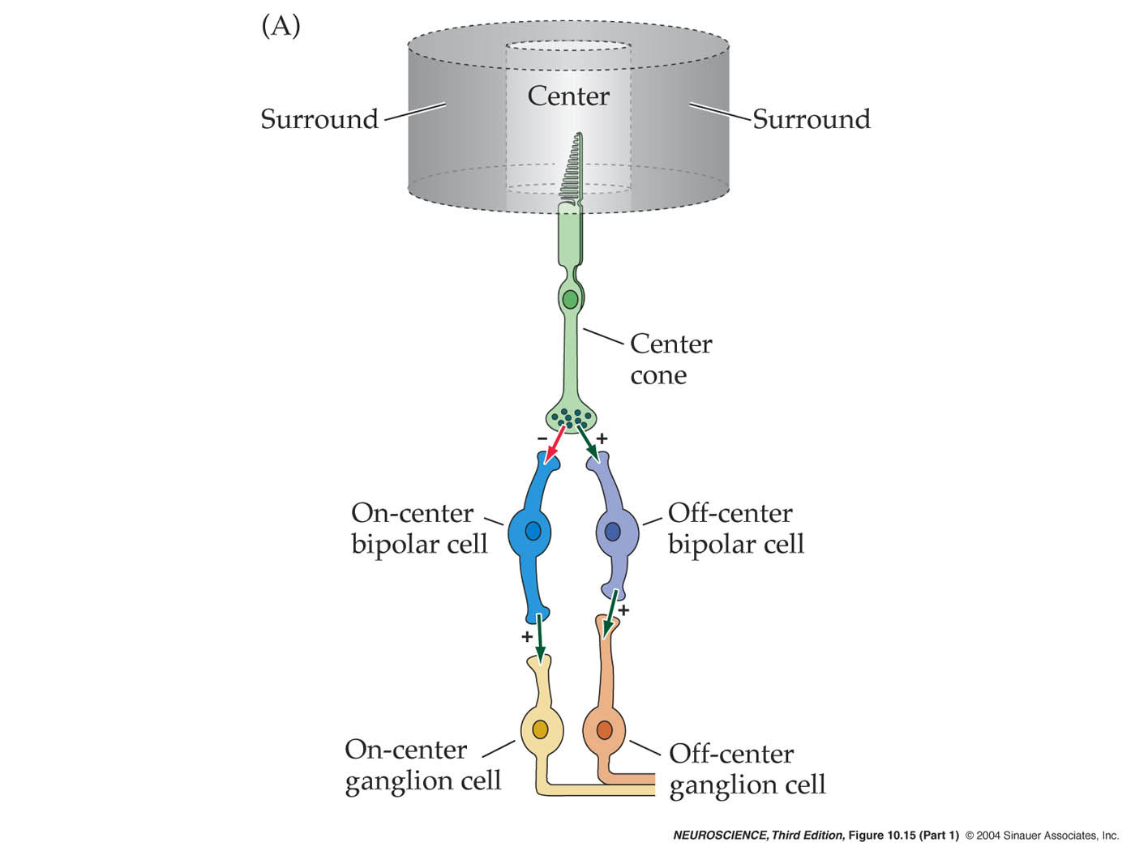
Glutamate
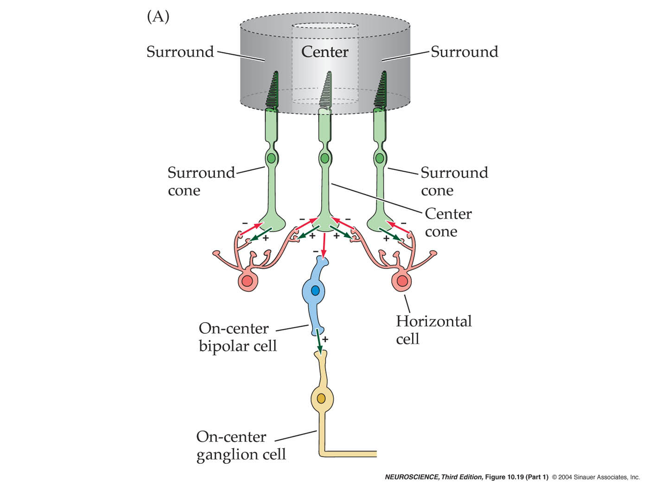

Amacrine cells are thought to modify temporal chracteristics.

At scotopic leels, rods project to bipolar rods. During mesopic light, rod current flows into cone synaptic terminals.

Ganglion cells collect at optic disk pierce the sclera at the lamina cribroa, acquire myelin sheaths and become the optic nerve.

Fibers from the nasal cross to the contralateral optic tract and the temporal parts stay ipsilateral at the chiasm. So, we retain contralateral visual fields.

LGN – CIICIC

Layer III to VI contain neurons sensitive to color and form and are called parvocellular.

Layers I and II are concerned with movement and contrast and known as magnocellular layers.

K cell layers are somehow involved in processing S-cone information?

LGN goes to the calcarine sulcus by way of the optic radiation. Superior visual quadrants go to inferior bank of calcarine by way of Meyer’s loop.

Each eye can see 90 degrees from tis visual axis in a temporal direction.

Hemianopia refers to ½, qudrantanopia to ¼

Homonymous is visual field loss is similar for both eyes.

Heteronumous means the two eyes have nonoverlapping field losses.

Damage anterior to the optic chiasm affects on the ipsilateral eye.

Damage at the chiasm causes heteronumous deficits and damage behin causes homonymous. At center (only crossing fibers) we get bitemporal hemianopia.

One optic tract causes homonymous hemianopia because everything from one visual field would be lost.

Macular sparing will spare the fovea even after large lesions because of its overrepresentation in the visual cortex.

Fibers in each optic tract that gypass the LGN pass over the MGN in a bundle called the branchium of the superior colliculus and head to th superior colliculus, pretectal rea, and other accessory optic nuclei.

The superior colliculus also gets somato inputs and auditory inputs (from inferior colliculus). Efferents go to reticular, cervical spinal, LGN, and pulvinar. Involved in reflexes of head to stimuli.

Small population of ganglion cells are directly photosenstivie and end in the suprachiasmatic nucleus and are important for circadian rhythm. SCN to Paraventricular to intermediolateral call column to superior cervical ganglion then to pineal for melatonin. (retinohypothalamic pathway)

Simple cells respond best to either dark bar on a light background or vice versa in a specific orientation.

Complex and hypercomplex cells respond to edges, bars, and corners with orientation and movement properties. This results from convergence.

Parvocellular (color, etc.) projects to ventral portions of extrastriate (more “what”). Magnocellular (movement, etc.) projects more dorsal (more “where”).

Critical period visual deprivation(even just depriving it of patterns) results in blindness.

Light directed into either eye causes both pupils(ipsi is direct, contra is consensual) to contract. The afferent limb of the reflex arc conssits of optic tract axons, mostly photosensitive ganglion cells that project to SCN. These enter the brachium of the superior colliculus and terminate in the pretectal area which is rostral to the superior colliculus at the junction between the midbrain and the diencephalon, which then projects to the edinger-westphal nucleus, with fibers crossing through the posterior commissure. Preganglionic parasympathetic neurons in the EW nucleus project through the occulomotor nerve to the ciliary ganglion, where they synapse. Postganglionic fibers in the short ciliary nerves complete the reflex arc by synapsing on the smooth sphincter pupillary muscles, causes the iris to contract.

Visual attention to a nearby object requires convergence so the image falls on both fovea. This requires ciliary muscle contraction and a thickening of the lens (accommodation) in order to focus. It also needs pupillary constriction which improves the opritcal performance of the eye by reducing certain types of aberration and increases its depth of focus.

Fovea is most posterior of V1 and central 10 degress cover 50% of V1.

