Repeated Measures ANOVA

---Traditionally, a lack of independence of treatments would undermine one of the fundamental assumptions of ANOVA, making the results suspect or invalid due to a correlation in observed scores.

---Partially out the effects of the individual, their individual difference, removes the dependence imposed by repeated measurements. Accounting for individual variation (SS_{B. Subjects}) removes the variation that would have otherwise been a part of with the error variation (SS_{Error)}. To sum, each person serves as their own control and reduces the overall error variation in predicting their score.

--The first source of error variance in the within-subjects design is random variance, traditional error. A second source of error variance is the correlation between the effect of the subject and the effect of the treatment, individual differences that are confounded with condition and are indiscernible from random error.

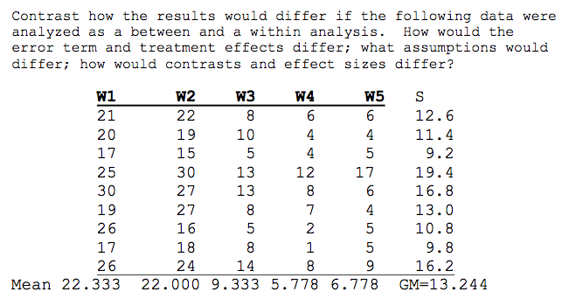
The different results derived from ANOVA and R-ANOVA are determined by the different approach each statistical test takes to account for and partitioning variance. First we notice differences in the number of subjects. Using ANOVA, this table reads that there are 45 subjects over 5 levels of treatment for a total of 45 observations. Using R-ANOVA this tables reads that there are 9 subjects over 5 levels of treatment for a total of 45 observations.
Next we notice differences in the calculation of sum of squares:
ANOVA | R-ANOVA
SS_{Total} = Σ (Y_{ij} – $\overline{Y}$)² = 3166.311 | SS_{Total} = Σ (Y_{ij} – $\overline{Y}$)² = 3166.311
SS_{Treatment} = (n) Σ ($\overline{Y}$_{j} – $\overline{Y}$)² = 2449.20 | SS_{Subjects} = (k) Σ ($\overline{Y}$_{s} – $\overline{Y}$)² = 486.71
SS_{Error} = (k) Σ ($\overline{Y}$_{ij} – $\overline{Y}$_{j})² = 717.11 | SS_{Treatment} = (n) Σ ($\overline{Y}$_{j} – $\overline{Y}$)² = 2449.20
 | SS_{Error} = SS_{Total} – (SS_{Subjects} + SS_{Treatment}) = 230.40

First, there is no difference in the total amount of variation between the two statistical models.
Second, there is no difference in the total amount of variation due to treatment effects.
Third, there is a difference in the amount of error variation between the two models. The R-ANOVA has a smaller error term that the ANOVA model.
Fourth, the R-ANOVA has a SS_{Subjects} which accounts for the variation caused by individual differences. Importantly, in R-ANOVA SS_{Subjects} + SS_{Error} = 717.11. Whereas in ANOVA SS_{Error} 717.11 showing us that R-ANOVA accounts for individual differences using SS_{Subjects} and reduces the overall error.

Then we notice differences in the corresponding degrees of freedom:
*n = subjects per treatment condition *k = number of treatment levels
ANOVA | R-ANOVA
DF_{Total} = (n * k) – 1 = 44 | DF_{Total} = (n * k) – 1 = 44
DF_{Treatment} = k – 1 = 4 | DF_{Subjects} = n – 1 = 8
DF_{Error} = (n – 1) * k = 40 | DF_{Treatment} = k – 1 = 4
 | DF_{Error} = DF_{Total} – (DF_{Subjects} + DF_{Treatment}) = 32
We are reminded of the additive properties of degrees of freedom.

These differences come to fruition in the calculation of the corresponding the Mean Squared terms and the omibus F-Test. In the case of these data, we fail to reject when using ANOVA, but reject using R-ANOVA.

Contrast are built and weighted the same way. However, when testing, the error term used in the denominator will be different, as the test have different error terms.

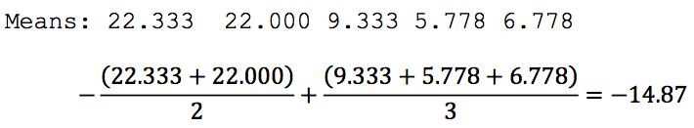
In ANOVA:
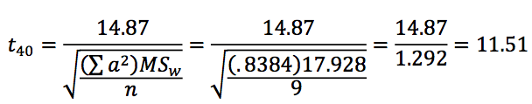

In R-ANOVA
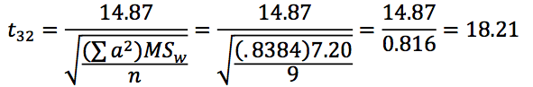

Note that both test used their corresponding MS_{Error}, but R-ANOVA has a smaller error term and larger effect.

Effect Size:

SS_{Subjects} = (Sum of each subject mean - the grand mean) times number of levels of treatment
SS_{Subjects} = (k) Σ ($\overline{Y}$_{s} – $\overline{Y}$)²

From total variance we can divide it into two parts, between subject variance and within subject variance. For the sake of this question, I will focus on within subject variance, but I do so knowing that it is not the full model of variance consists of both.
Within subject variance consists of:
Variance due to subject – Individual differnces that are captured in SS_{Subjects}
Variance due to random error – Noise that is captured in SS_{Error}
Interaction between subject and treatment – Confound created at the intersection of individuals varying due to treatment. This cannot be portioned out and is folded into the SS_{Error} term.

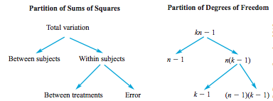

Model I: Y_{ij} = μ + π_{i} + τ_{j} + e_{ij}
Observed = Grand Mean + Effect of Subject + Effect of Treatment + Error
Breakdown of single and noise in Model I
Source | E(MS)
Subject | $$σ_{e}^{2}+kσ_{π}^{2}$$
Treatment | $$σ_{e}^{2}+nθ_{τ}^{2}$$
Error | $$σ_{e}^{2}$$

Model II: Y_{ij} = μ + π_{i} + τ_{j} + πτ_{ij} + e_{ij}
Observed = Grand Mean + Subject Effect + Treatment Effect + Effect of Subject*Treatment Interaction + Error
Where random error and the Subject*Treatment interaction cannot be interpreted separately from error.
Breakdown of single and noise in Model II
Source | E(MS)
Subject | $$σ_{e}^{2}+kσ_{π}^{2}$$
Treatment | $$σ_{e}^{2}+nθ_{τ}^{2}+σ_{πτ}^{2}$$
Error | $σ_{e}^{2}$+ $σ_{πτ}^{2}$
To note, Treatment and Error show the addition of the error variance from the Subject*Treatment interaction.

The Subject*Treatment interaction denotes that different subjects to change differently across the levels of the treatment. That is, everyone is not impacted by the treatment in a uniform manner.

In the words of Howell, “The main reason for obtaining SS_{subject} in the first place is to absorb the correlations between treatments and thereby remove subject differences from the error term. A test on the Subject effect, if it were significant, would merely indicate that people are different—hardly a momentous finding.”

SS_{Subject} allows us to violate the assumptions that observations are independent by accounting for dependence of observations. In the same vain, SS_{Subject} captures individual differences are removes them from the error term.

Compound symmetry is additive to the assumption of homogeneity of variance. The assumption of compound symmetry says that variances are equal, and, in addition, the covariances are equal. To note, if we have compound symmetry we also have sphericity, but having sphericity does not mean that we will also have compound symmetry. Lastly, variances do not have to equal covariances.

Looking at the covariance matrix below, the variances are equal (h. of variance) in addition the covariances are also equal, giving us compound symmetry.

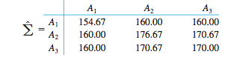

Sphericity states that the variance of the differences between treatment A₁ and A₂ equals the variance of the difference between A₁ and A₃, which equals the variance of the differences between A₂ and A₃. Succinctly, all possible pairs of difference scores have equal variance.

The main point, the standard error of the distribution of mean differences is smaller, and thus you get more power in your tests. Adding theory, according to variance sum law, as the degree of correlation among treatment levels increases the smaller the variance of the sampling distribution of mean differences is. (Because mean differences equal one level plus next level, minus two times correlation – higher correlation, the more subtracted out).

Contrast use the error term derived from the statistical model, MS_{Error}.
Calculating effect size is tricky for contrast in R-ANOVA, as one must create a unique standard error. Taking the standard deviation of the means of the baseline scores you want to compare, creating your standard error term for the contrast. A similar process would need to take place for each contrast.

Multiple Repeated Measures MANOVA

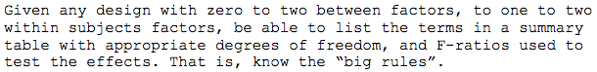
The Big Rules of interpreting R-MANOVA tables:
*Using a MR-MANOVA, Two Within and Two Between Subjects, as an example.
(A * B) * (G * H)
Between Subtable – See Between Sources
1. The total degrees of freedom in the between subtable equals the total number of subjects (N)
2. The between subtable includes all treatment conditions and their interactions.
3. The between subtable has a single error term, MS_{subjects} which is used as the denominator for all F-test of treatment effects.

Within Subtable
1. The total degrees of freedom in the within subtable equals the total number of scores – total number of subjects (N)
2. The within subtable includes the each repeated measures variables and each repeated measure’s interaction with each treatment condition (from the between subtable).
3. Each repeated measure variable has its own error term, its interaction with subjects. This same error, (interaction with subject), this same error is used for each repeated measure*treatment condition interaction.
Testing Main Effects & Interaction
1. Testing treatment condition = number of levels – 1 = k – 1
2. Testing Subject Effect, degrees of freedom = n – 1 * product of number of level of each between variable
3. For interactions, the degrees of freedom = product of corresponding main effects.

Epsilon (ε) – correction factor for degrees of freedom. Epsilon is a bound constant (0-1) that we multiply our degrees of freedom with (always making it smaller)
As we violate the assumption of sphericity, we must reduce our allowance of degrees of freedom. Greenhouse & Geisser and Huynh Feldt are adjustments for degrees of freedom to correct from the departure of ε = 1
Greenhouse – Underestimates our degrees of freedom (appropriately conservative).
Huyhn – Overestimates our degrees of freedom (too liberal).
Lower Bound – Gives us the lowest possible degrees of freedom (extremely conservative).

First, a simple effect is the effect of one factor conditional on the level of the other factors.
Between Subjects Variables, Simple Effects:
When testing on one level of a within subject factor, the analysis becomes a between ANOVA. Thus, the error term should be MS_{Within}, but MS_{Subject} is not sufficient. That is it controls for too much variance, and noise needs to be added back in.
*That is, subject differences are confounded with experimental error.
-- SS_{Within} = SS_{Subjects} + SS_{Treatment*Subject}, (average within group variance across levels of within subject favtor).
--Howell recommends the Welch & Satterthwaite procedure for computing F’

Within Subjects Variables, Simple Effects:
The assumption of sphericity becomes especially important for test of simple effects. Why?
--Test of simple effects use MS_{error} (the interaction of subjects and treatments), but this would become problematic if the covariances of a factor are not equal across levels of another factor.
----The solution, derive a separate error term for each simple effect tested, as we did for the test of contrast. This can be done by running a R-ANOVA on a single level of the particular factor(s) your interested in. (Removes interaction of between and within variables.)
*This situation is another reason why degrees of freedom corrections are so important, correct error in epsilon.

Between Subjects Partial Eta Squared
$$\frac{{SS}_{B. Factor}}{{SS}_{Total}}$$
Variation due to B. Factor over total variation

Within Subjects Partial Eta Squared
$$\frac{{SS}_{W. Factor}}{{SS}_{Total}-{SS}_{Subject}}$$
Variation due to W. Factor over total variation – variation due to individual differences.
*Often oddly small because we control for individual differences.

Place Holder

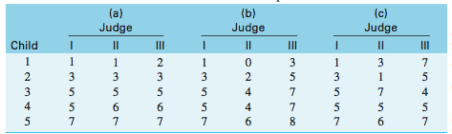

Judge A – Shows a high consistency and high agreement
Judge B – Shows high consistency, but low agreement.
Judge C – Shows low consistency and low agreement

Place Holder

X_{ij} = μ + α_{i} + π_{j} + απ_{ij} + e_{ij}
Observed score = grandmen + Effect of Judge + Effect of Subject + Judge*Subject Interaction + Error. **Where error and the interaction cannot be calculated separately.

This ration should be close to 1.00 if the variability in scores is due to differences between subjects, and not differences in judges $(σ_{α}^{2})$, difference in judge*Subject interaction $(σ_{πα}^{2})$, or differences due to error $(σ_{ε}^{2})$

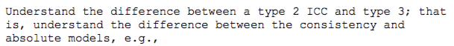

Type 2 Interclass correlation only takes into account consistency and agreement.

Place Holder

Type 3 Interclass correlation only takes into account consistency.

Place Holder

Regression
In the population, r, the correlation of X and Y, is equal to the covariance of X and Y over the product of the standard deviation of X and Y. Where covariance is the average of the cross products. The equation can be restructured to read: r = sum (product of standardized X and Y scores) over N (subjects in population).

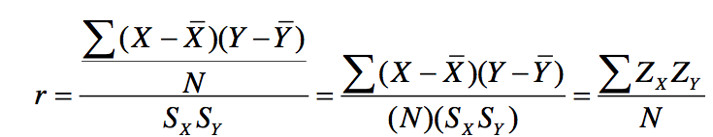
Correlations are preferred over covariances because the covariance metric is often nonsensical.

Also, we remember that regression is a test of the linear relationship of X and Y, and is based on the principle of ‘least squares;’ seeking to minimize the sum of squared differences between X and Y.

Standardized Regression Equation: ${\hat{Z}}_{Y}= r_{XY}(Z_{x})$
${\hat{Z}}_{Y}$= Predicted score in the population
$r_{XY}$ = Correlation in the population
$Z_{x}$ = Score on X in the population

Unstandardized Regression Equation: $\hat{Y}= a+b(X)$
$\hat{Y}$ = Predicted score
a = Intercept. Value of $\hat{Y}$ when X = 0; $a= \overline{Y}-b\overline{X}$
b = Slope. Ratio change $\hat{Y}$ in due to score on X; $b= \frac{{cov}_{xy}}{s_{x}^{2}}$
X = Value on variable X.

Regression to the mean is the phenomenon that if a variable is extreme on its first measurement, it will tend to be closer to the average on its second measurement—and, paradoxically, if it is extreme on its second measurement, it will tend to have been closer to the average on its first.

Standard Error of Estimate $(S_{Y|x})$ is the average error of predicting Y from X. It can be calculated as the standard deviation $\hat{Y}$ scores. ${(S_{Y|x})}^{2}$ = Error (or Residual) Variance

$$S_{Y|x}= \sqrt{\frac{{Σ(Y- \hat{Y})}^{2}}{N-2}}= \sqrt{\frac{{SS}_{res}}{df}}$$
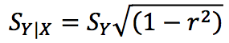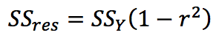

SS_{Tot} = Summed (difference of Observed Y from Grand Mean)²
SS_{Tot} = Σ$(Y- \overline{Y}$)² (df = N -1)
SS_{reg} = Summed (differences of Predicted Y from Grand Mean)²
SS_{reg} = Σ$(\hat{Y}- \overline{Y}$)². (df = 1)
r² = percent reduction in error of predicting Y from X
r² = SS_{reg}/SS_{tot} = Σ$(\hat{Y}- \overline{Y}$)² / Σ$(Y- \overline{Y}$)²
SS_{res} = Sum of squares error
SS_{res} = Σ$(Y- \hat{Y}$)² or SS_{Tot} (1 – r²) (df = N-2)

Prediction Interval (blue) – Confidence Interval from predicted Y. Considers the uncertainty of the mean of Y conditional on X, and the variability of observations around the predicted Y.
For a few individual
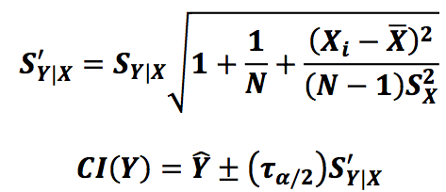
Regression Interval (green) – Confidence Interval for the conditional means (the regression line)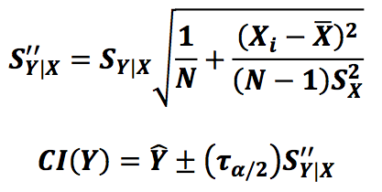

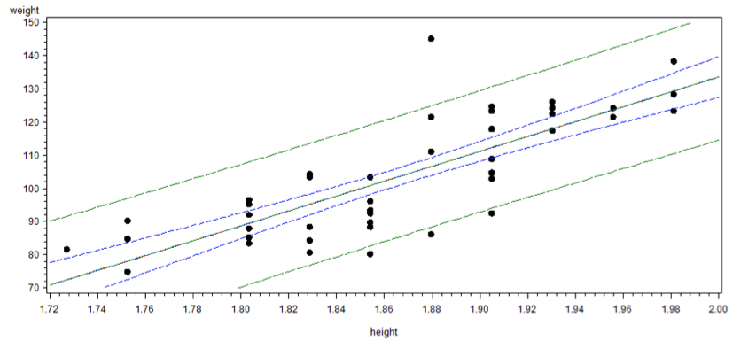

Homogeneity of variance assumes standard deviations of the error terms are constant and do not depend on the x-value. If this was violated the regression line would be useless in predicting Y on X as there would be more error variability of some values on X than on others and ruin the calculation of the slope and the intercept.

To note, this is testing two slopes in different samples. Not testing two predictors!

Multiple Regression

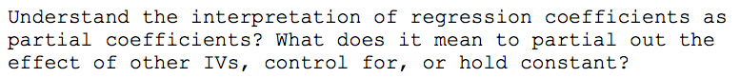

Partial Regression coefficients – The unique percent reduction in error on Y controlling for the other predictors. That is, looking at the relation of X and Y at the specific value of other predictors—controlling for other sources of variation.

Multiple R = Correlation between Y and $\hat{Y}$ (The best linear composite estimate)
R² = Precent of variance in Y explained by the linear combination of predictors (Xs)

df_{Tot} = N-1, df_{Reg} = p, df_{res} = N – p -1

